INTRODUCTION TO JAVA
WEEK 3: INTRO TO SOFTWARE DEVELOPMENT LIFE CYCLE
DAY 1: SDLC OVERVIEW AND INTRODUCTION

WHAT IS SDLC

SDLC Overview
Software Development Life Cycle (SDLC) is a process used by the software industry to design, develop and test high quality software. The SDLC aims to produce a high-quality software that meets or exceeds customer expectations, reaches completion within times and cost estimates.

SDLC is the acronym of Software Development Life Cycle.
It is also called as Software Development Process.
SDLC is a framework defining tasks performed at each step in the software development process.
ISO/IEC 12207 is an international standard for software life-cycle processes. It aims to be the standard that defines all the tasks required for developing and maintaining software.
History of the SDLC
The profession of “software developer” has existed since the first computers, and their operators, as far back as the days of ENIAC and vacuum tubes. Practices and methods for developing software have evolved over the decades since the invention of the computer. Those methods have adapted to the state of the art in computer hardware, development tools, and modern thinking about the organizational management of software development teams. With this progress, new methods of software development have grown out of private and public software development efforts around the world. These methods vary widely in approach, yet they share a common goal: to develop software as cheaply, efficiently, and effectively as possible.

What is the SDLC?
Software is a complex product that is developed and delivered through a series of steps. That is the one thing all the various methods have in common: one way or another, software, like all products, starts as an idea. The idea then becomes a document, or perhaps a prototype, depending on the method in use. Whether a document, diagram, or working software, the artifact created in one step becomes the input to the next step. Eventually, the software is delivered to the customer. The sequence of steps used by these methods is commonly referred to as the Software Development Lifecycle (SDLC.)

How does the SDLC work?
The process of software development is a never-ending cycle. The first release of a software application is rarely “finished.” There are almost always additional features and bug fixes waiting to be designed, developed, and deployed.

Reports from error monitoring software about usability and bugs feed back into the process of software development, and become new feature requests and improvements to existing features. This is why the Software Development Life Cycle is the most general term for software development methods. The steps of the process and their order vary by method. Regardless of method, they typically run in cycles, starting over with each iteration.

It’s very difficult to carry out a complex, team effort such as software development without some kind of plan. Each software development methodology (several will be detailed below) is a plan framework for how to develop software. There is much debate about which method is best overall, which is best suited to a particular type of software, and how to measure success in software development. One thing, however, is certain: any plan is better than no plan.

Without some kind of structured plan, software development teams tend to devolve into a “herd of cats.” Developers don’t know what they’re supposed to create. Project managers have no idea how much progress is made towards completion of a project. Without a plan, the business doesn’t even have a way to decide whether the final product meets their requirements.

WHAT ARE THE BENEFITS OF USING SDLC?

The Software Development Life Cycle (SDLC) is a systematic process for planning, creating, testing, deploying, and maintaining software. There are several benefits to using SDLC in software development:

1. **Structured Approach:**
- SDLC provides a structured and organized approach to software development. It breaks down the entire process into distinct phases, making it easier to understand, plan, and execute.

2. **Better Planning and Management:**
- SDLC enables better project planning and management. It helps in defining project scope, estimating costs and resources, and establishing realistic timelines. This leads to more accurate project planning and better management of resources.

3. **Risk Management:**
- SDLC includes risk assessment and management throughout the development process. Identifying and addressing potential risks early in the development life cycle helps in minimizing the impact of issues on the project.

4. **Quality Assurance:**
- SDLC includes testing and validation at various stages. This ensures that defects and issues are identified and addressed early in the development process, resulting in higher software quality.

5. **Clear Documentation:**
- Each phase of SDLC requires documentation. This documentation serves as a reference for developers, testers, and other stakeholders. It helps in maintaining clarity regarding project requirements, design, and implementation details.

6. **Effective Communication:**
- SDLC promotes effective communication among team members and stakeholders. By defining clear requirements, specifications, and milestones, team members can understand their roles and responsibilities, leading to better collaboration.

7. **Customer Satisfaction:**
- Following a systematic SDLC helps in delivering a product that aligns with customer expectations. It ensures that requirements are well understood, and the delivered software meets the specified criteria, leading to higher customer satisfaction.

8. **Change Management:**
- SDLC provides a framework for managing changes to the project scope or requirements. Changes can be evaluated, documented, and implemented in a controlled manner, minimizing the risk of introducing errors or delays.

9. **Cost Control:**
- SDLC helps in estimating and controlling project costs more effectively. By identifying and addressing issues early in the development process, the overall cost of development is reduced.

10. **Facilitates Maintenance and Upgrades:**
- SDLC supports the ongoing maintenance and upgrading of software. The structured approach makes it easier to understand the existing system, identify areas for improvement, and implement changes without disrupting the entire system.
THE SEVEN IMPORTANT PHASES OF SDLC

The Seven Phases of the SDLC
These steps are (very) roughly the same from one methodology to another. They tend to occur in this order, though they can also be mixed together, such that several steps occur in parallel.

As we’ll discuss later, Agile methods tend to “wind together” all of these steps into a tight, rapidly-repeating cycle. Waterfall methods tend to take each of these steps in turn. Outputs from one become inputs to the following step.

The following figure is a graphical representation of the various stages of a typical SDLC.

SDLC Image

1. Requirements Analysis/Planning

The planning phase involves aspects of project and product management. This may include:

Resource allocation (both human and materials)

Capacity planning
Project scheduling
Cost estimation
Provisioning
The outputs of the planning phase include: project plans, schedules, cost estimations, and procurement requirements. Ideally, Project Managers and Development staff collaborate with Operations and Security teams to ensure all perspectives are represented.

2. Defining/Feasibility

The business must communicate with IT teams to convey their requirements for new development and enhancement. The requirements phase gathers these requirements from business stakeholders and Subject Matter Experts (SMEs.)

There are mainly five types of feasibility checks:

Economic: Can we complete the project within the budget or not?
Legal: Can we handle this project as cyber law and other regulatory framework/compliance.
Operation feasibility: Can we create operations which is expected by the client?
Technical: Need to check whether the current computer system can support the software
Schedule: Decide that the project can be completed within the given schedule or not.
Architects, Development teams, and Product Managers work with the SMEs to document the business processes that need to be automated through software. The output of this phase in a Waterfall project is usually a document that lists these requirements. Agile methods, by contrast, may produce a backlog of tasks to be performed.

3. Design and prototyping

Once the requirements are understood, software architects and developers can begin to design the software. The design process uses established patterns for application architecture and software development. Architects may use an architecture framework such as TOGAF to compose an application from existing components, promoting reuse and standardization.

Developers use proven Design Patterns to solve algorithmic problems in a consistent way. This phase may also include some rapid prototyping, also known as a spike, to compare solutions to find the best fit. The output of this phase includes:

Design documents that list the patterns and components selected for the project
Code produced by spikes, used as a starting point for development
There are two kinds of design documents developed in this phase:

High-Level Design (HLD)
Brief description and name of each module
An outline about the functionality of every module
Interface relationship and dependencies between modules
Database tables identified along with their key elements
Complete architecture diagrams along with technology details
Low-Level Design (LLD)
Functional logic of the modules
Database tables, which include type and size
Complete detail of the interface
Addresses all types of dependency issues
Listing of error messages
Complete input and outputs for every module
4. Coding/Software development

This phase produces the software under development. Depending on the methodology, this phase may be conducted in time-boxed “sprints,” (Agile) or may proceed as a single block of effort (Waterfall.) Regardless of methodology, development teams should produce working software as quickly as possible. Business stakeholders should be engaged regularly, to ensure that their expectations are being met. The output of this phase is testable, functional software.

5. Testing

The testing phase of the SDLC is arguably one of the most important. It is impossible to deliver quality software without testing. There is a wide variety of testing necessary to measure quality:

Code quality
Unit testing (functional tests)
Integration testing
Performance testing
Security testing
The best way to ensure that tests are run regularly, and never skipped for expediency, is to automate them. Tests can be automated using Continuous Integration tools, like Codeship, for example. The output of the testing phase is functional software, ready for deployment to a production environment.

6. Deployment

The deployment phase is, ideally, a highly automated phase. In high-maturity enterprises, this phase is almost invisible; software is deployed the instant it is ready. Enterprises with lower maturity, or in some highly regulated industries, the process involves some manual approvals. However, even in those cases it is best for the deployment itself to be fully automated in a continuous deployment model. Application Release Automation (ARA) tools are used in medium and large-size enterprises to automate the deployment of applications to Production environments. ARA systems are usually integrated with Continuous Integration tools. The output of this phase is the release to Production of working software.

7. Operations and maintenance

The operations and maintenance phase are the “end of the beginning,” so to speak. The Software Development Life Cycle doesn’t end here. Software must be monitored constantly to ensure proper operation. Bugs and defects discovered in Production must be reported and responded to, which often feeds work back into the process. Bug fixes may not flow through the entire cycle, however, at least an abbreviated process is necessary to ensure that the fix does not introduce other problems (known as a regression.)

11. **Regulatory Compliance:**
- For projects in industries with regulatory requirements (e.g., healthcare, finance), following a well-defined SDLC helps in ensuring compliance with industry standards and regulations.

In summary, the use of SDLC provides a systematic and organized approach to software development, leading to improved project planning, better risk management, higher software quality, and increased overall efficiency in the development process.

DAY 2: POPULAR SDLC MODELS
SDLC MODELS

Popular SDLC Models
This SDLC model is documentation-intensive, with earlier phases documenting what need be performed in the subsequent phases. Here, are some most important phases of SDLC life cycle:

1. V-Model

The V-model is an SDLC model where execution of processes happens in a sequential manner in a V-shape. It is also known as Verification and Validation model. The V-Model is an extension of the waterfall model and is based on the association of a testing phase for each corresponding development stage. This means that for every single phase in the development cycle, there is a directly associated testing phase. This is a highly-disciplined model and the next phase starts only after completion of the previous phase.

V-Model - Design
Under the V-Model, the corresponding testing phase of the development phase is planned in parallel. So, there are Verification phases on one side of the ‘V’ and Validation phases on the other side. The Coding Phase joins the two sides of the V-Model.

The following illustration depicts the different phases in a V-Model of the SDLC.

V Model Image

There are several Verification phases in the V-Model, each of these are explained in detail below.

Business Requirement Analysis
This is the first phase in the development cycle where the product requirements are understood from the customer’s perspective. This phase involves detailed communication with the customer to understand his expectations and exact requirement. This is a very important activity and needs to be managed well, as most of the customers are not sure about what exactly they need. The acceptance test design planning is done at this stage as business requirements can be used as an input for acceptance testing.

System Design
Once you have the clear and detailed product requirements, it is time to design the complete system. The system design will have the understanding and detailing the complete hardware and communication setup for the product under development. The system test plan is developed based on the system design. Doing this at an earlier stage leaves more time for the actual test execution later.

Architectural Design
Architectural specifications are understood and designed in this phase. Usually more than one technical approach is proposed and based on the technical and financial feasibility the final decision is taken. The system design is broken down further into modules taking up different functionality. This is also referred to as High Level Design (HLD).

The data transfer and communication between the internal modules and with the outside world (other systems) is clearly understood and defined in this stage. With this information, integration tests can be designed and documented during this stage.

Module Design
In this phase, the detailed internal design for all the system modules is specified, referred to as Low Level Design (LLD). It is important that the design is compatible with the other modules in the system architecture and the other external systems. The unit tests are an essential part of any development process and helps eliminate the maximum faults and errors at a very early stage. These unit tests can be designed at this stage based on the internal module designs.

WHAT ARE THE PRO AND CONS OF USING V-MODEL?

The V-Model, also known as the Verification and Validation model, is a software development and testing process that follows a sequential path. It is an extension of the Waterfall model and emphasizes the verification and validation of the product at each stage of the development life cycle. Here are the pros and cons of using the V-Model:

### Pros of V-Model:

1. **Clarity and Simplicity:**
- The V-Model is straightforward and easy to understand. It provides a clear path of execution and a well-defined set of activities for each phase of development.

2. **Early Detection of Defects:**
- Testing activities are integrated into each phase of development, allowing for the early detection and correction of defects. This can result in higher software quality.

3. **Explicit Documentation:**
- The V-Model emphasizes the creation of documentation at each stage, ensuring that requirements, design, and testing criteria are well-documented. This can aid in better understanding and future maintenance.

4. **Parallel Development and Testing:**
- Development and testing activities occur in parallel, allowing for a more efficient use of resources and reducing the overall project timeline.

5. **Measurable Progress:**
- The V-Model provides a structured approach with measurable milestones at each stage. This helps in tracking progress and managing the project effectively.

6. **Client Involvement:**
- Since testing activities are integrated throughout the development life cycle, clients can be involved in the verification and validation process, providing valuable feedback at an early stage.

### Cons of V-Model:

1. **Rigidity and Inflexibility:**
- The V-Model is often criticized for its rigidity. Once a phase is complete, it is challenging to go back and make changes without affecting the entire process.

2. **Limited Flexibility for Changes:**
- Changes in requirements or design after the project has started can be costly and time-consuming to implement. The V-Model is less accommodating to changes compared to more iterative models.

3. **Late Feedback from Users:**
- User feedback may be delayed until the testing phase, which can lead to late identification of requirements issues or misunderstandings.

4. **Not Suitable for Large Projects:**
- The V-Model may not be suitable for large and complex projects where requirements are likely to evolve. Adapting to changing requirements can be challenging.

5. **Resource Intensive:**
- The testing phase may require significant resources, particularly if defects are identified late in the process. This can lead to increased testing efforts and costs.

6. **Dependence on Early Specifications:**
- The success of the V-Model depends on the accuracy and completeness of the initial specifications. If the requirements are unclear or incomplete, it can lead to difficulties in later stages.

7. **Limited Client Involvement in Early Stages:**
- While the V-Model allows for client involvement in testing, there is limited client involvement in the early stages, which may result in misunderstandings or changes later in the process.

In summary, the V-Model is suitable for certain types of projects where requirements are well-understood and unlikely to change. However, its rigidity and limited flexibility make it less suitable for projects with evolving or uncertain requirements. Careful consideration of project characteristics and requirements is essential when deciding whether to use the V-Model.

2. Spiral Model
The spiral model is a risk-driven process model. This SDLC model helps the team to adopt elements of one or more process models like a waterfall, incremental, waterfall, etc. This model adopts the best features of the prototyping model and the waterfall model. The spiral methodology is a combination of rapid prototyping and concurrency in design and development activities.
The following illustration is a representation of the Spiral Model, listing the activities in each phase.
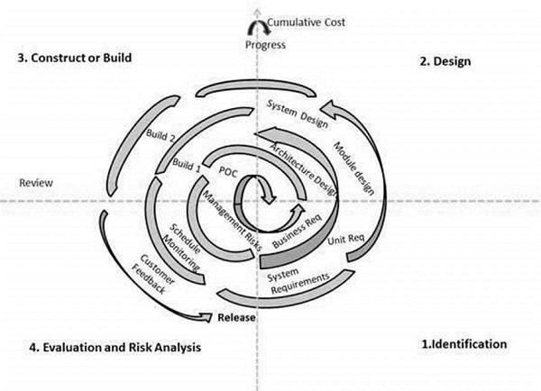
The spiral model has four phases. A software project repeatedly passes through these phases in iterations called Spirals.

Identification
This phase starts with gathering the business requirements in the baseline spiral. In the subsequent spirals as the product matures, identification of system requirements, subsystem requirements and unit requirements are all done in this phase. This phase also includes understanding the system requirements by continuous communication between the customer and the system analyst. At the end of the spiral, the product is deployed in the identified market.

Design
The Design phase starts with the conceptual design in the baseline spiral and involves architectural design, logical design of modules, physical product design and the final design in the subsequent spirals.

Construct or Build
The Construct phase refers to production of the actual software product at every spiral. In the baseline spiral, when the product is just thought of and the design is being developed a POC (Proof of Concept) is developed in this phase to get customer feedback. Then in the subsequent spirals with higher clarity on requirements and design details a working model of the software called build is produced with a version number. These builds are sent to the customer for feedback.

Evaluation and Risk Analysis
Risk Analysis includes identifying, estimating and monitoring the technical feasibility and management risks, such as schedule slippage and cost overrun. After testing the build, at the end of first iteration, the customer evaluates the software and provides feedback.
3. Big bang model
Big bang model is focusing on all types of resources in software development and coding, with no or very little planning. The requirements are understood and implemented when they come. This model works best for small projects with smaller size development team which are working together. It is also useful for academic software development projects. It is an ideal model where requirements are either unknown or final release date is not given.

Big Bang Model - Pros and Cons
The advantage of this Big Bang Model is that it is very simple and requires very little or no planning. Easy to manage and no formal procedure are required. However, the Big Bang Model is a very high-risk model and changes in the requirements or misunderstood requirements may even lead to complete reversal or scraping of the project. It is ideal for repetitive or small projects with minimum risks.
The advantages of the Big Bang Model are as follows:
- This is a very simple model
- Little or no planning required
- Easy to manage
- Very few resources required
- Gives flexibility to developers
- It is a good learning aid for new comers or students.
The disadvantages of the Big Bang Model are as follows:
- Very High risk and uncertainty.
- Not a good model for complex and object-oriented projects.
- Poor model for long and ongoing projects.
- Can turn out to be very expensive if requirements are misunderstood.
4. Waterfall model
The waterfall is a widely accepted SDLC model. In this approach, the whole process of the software development is divided into various phases. In this SDLC model, the outcome of one phase acts as the input for the next phase.
Waterfall methodology begins with long planning and design phases. Once developed, the software then goes through phases of testing, and is finally deployed for use. Waterfall is considered by many to be too rigid to adapt to changing requirements. It does not support feedback throughout the process, leading to the implementation of requirements that may have changed during the development effort. This weakness in Waterfall led to the development of more flexible methodologies, such as Agile.
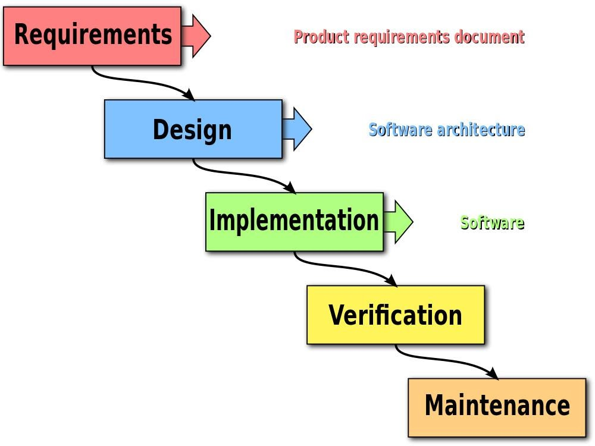
The Waterfall method of software development follows a rigid, predetermined path through a set of phases. This method was adapted from traditional engineering. Ironically, the paper credited as the origin of the Waterfall method, describes it as being fundamentally flawed. The method that is known today as “Waterfall” was mistakenly derived from a misunderstanding of this original work. Despite that fact, Waterfall became a very common, even standard methodology for large projects around the world.

Waterfall Model - Advantages
- The advantages of waterfall development are that it allows for departmentalization and control. A schedule can be set with deadlines for each stage of development and a product can proceed through the development process model phases one by one.
- Development moves from concept, through design, implementation, testing, installation, troubleshooting, and ends up at operation and maintenance. Each phase of development proceeds in strict order.
- Some of the major advantages of the Waterfall Model are as follows −
- Simple and easy to understand and use
- Easy to manage due to the rigidity of the model. Each phase has specific deliverables and a review process.
- Phases are processed and completed one at a time.
- Works well for smaller projects where requirements are very well understood.
- Clearly defined stages.
- Well understood milestones.
- Easy to arrange tasks.
- Process and results are well documented.

DISADVANTAGES FOR USING A WATERFALL MODEL IN SOFTWARE DEVELOPMENT

The waterfall model, though once widely used, has several disadvantages that led to the development and adoption of more flexible and iterative methodologies. Here are some drawbacks of the waterfall model:

1. **Rigidity and Inflexibility:**
- The waterfall model follows a linear and sequential approach, which makes it inflexible to changes once the development process has started. It's challenging to go back to a previous phase to make modifications without affecting the entire process.

2. **Limited Customer Involvement:**
- Customer involvement is typically limited to the beginning and end of the project. This can lead to misunderstandings and result in a product that doesn't meet the customer's evolving needs or expectations.

3. **Late Visibility of the Product:**
- Stakeholders do not see a working version of the product until the later stages of development. This lack of early visibility can lead to surprises or mismatches between the final product and the initial requirements.

4. **High Risk of Project Failure:**
- If requirements are not well understood or change significantly during development, it can lead to a high risk of project failure. Any misunderstanding or mistake in the early stages can have a cascading effect on the rest of the development process.

5. **Difficulty in Accommodating Changes:**
- Incorporating changes after the project has started is challenging and expensive. The rigid structure of the waterfall model makes it difficult to accommodate changes in requirements, and doing so may require going back to the beginning of the development process.

6. **Long Delivery Time:**
- The linear nature of the waterfall model often results in longer delivery times, as each phase must be completed before moving on to the next. This can be a significant drawback in today's fast-paced and dynamic business environment.

7. **Testing is Deferred to the End:**
- Testing is typically deferred until the end of the development process, which means that defects and issues may not be discovered until late in the project. This can lead to increased costs and time delays for fixing problems.

8. **Client Feedback is Obtained Late:**
- Since client feedback is often obtained after the entire system is developed, incorporating changes based on feedback can be time-consuming and costly.

9. **High Documentation Overhead:**
- The waterfall model requires extensive documentation at each stage of the development process. This documentation overhead can be time-consuming and may not add significant value, especially in projects where requirements are subject to change.

10. **Not Suitable for Large Projects:**
- The waterfall model may not be suitable for large and complex projects where requirements are likely to change or evolve over an extended period.

Due to these limitations, many software development teams now prefer more agile and iterative methodologies that allow for flexibility, frequent customer feedback, and incremental development.

DAY 3: SDLC MODELS
5. Agile Model
Agile methodology is a practice which promotes continue interaction of development and testing during the SDLC process of any project. In the Agile method, the entire project is divided into small incremental builds. All of these builds are provided in iterations, and each iteration lasts from one to three weeks. The Manifesto for Agile Software Development was drafted and signed by a group of software developers in 2001. Reading the manifesto, you can see clearly the contrast between Waterfall, then the de-facto standard for development methods, and Agile, the newer method.
The Manifesto addresses key problems with Waterfall that led to challenges in software delivery. Where Waterfall tends to be a “one-way road,” Agile is a more flexible framework that allows for uncertainty. Agile emphasizes teamwork, prototyping, and feedback loops that can change the direction of the development effort in response to changing requirements. Several variants of Agile have emerged since the signing of the Manifesto. Scrum defines specific roles and events, known as ceremonies, as part of its practice. Kanban is simpler, with fewer prescriptions and more flexibility. Agile teams often combine these together to adapt a bespoke process that fits them best.
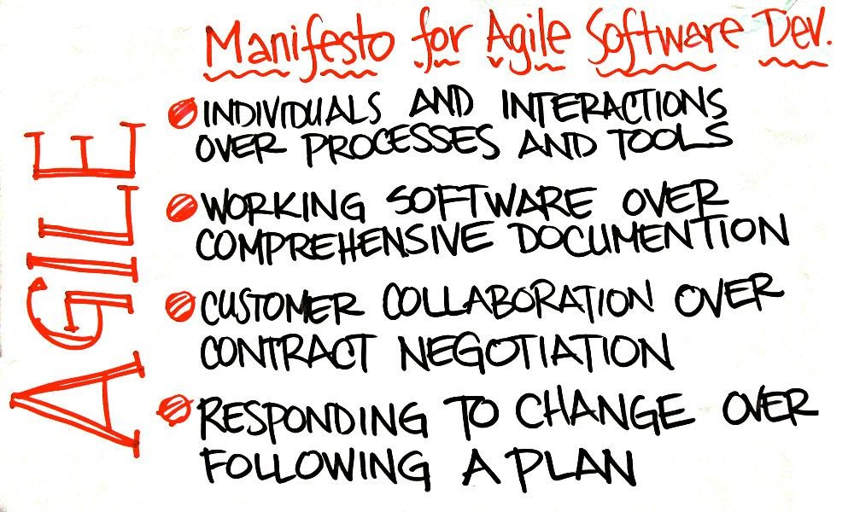
The most popular Agile methods include Rational Unified Process (1994), Scrum (1995), Crystal Clear, Extreme Programming (1996), Adaptive Software Development, Feature Driven Development, and Dynamic Systems Development Method (DSDM) (1995). These are now collectively referred to as Agile Methodologies, after the Agile Manifesto was published in 2001.

Following are the Agile Manifesto principles
Individuals and interactions − In Agile development, self-organization and motivation are important, as are interactions like co-location and pair programming.
Working software − Demo working software is considered the best means of communication with the customers to understand their requirements, instead of just depending on documentation.
Customer collaboration − As the requirements cannot be gathered completely in the beginning of the project due to various factors, continuous customer interaction is very important to get proper product requirements.
Responding to change − Agile Development is focused on quick responses to change and continuous development.

Agile Model - Pros and Cons
Agile methods are being widely accepted in the software world recently. However, this method may not always be suitable for all products. Here are some pros and cons of the Agile model.

The advantages of the Agile Model are as follows
- Is a very realistic approach to software development.
- Promotes teamwork and cross training.
- Functionality can be developed rapidly and demonstrated.
- Resource requirements are minimum.
- Suitable for fixed or changing requirements
- Delivers early partial working solutions.
- Good model for environments that change steadily.
- Minimal rules, documentation easily employed.
- Enables concurrent development and delivery within an overall planned context.
- Little or no planning required.
- Easy to manage.
- Gives flexibility to developers.

The disadvantages of the Agile Model are as follows
- Not suitable for handling complex dependencies.
- More risk of sustainability, maintainability and extensibility.
- An overall plan, an agile leader and agile PM practice is a must without which it will not work.
- Strict delivery management dictates the scope, functionality to be delivered, and adjustments to meet the deadlines.
- Depends heavily on customer interaction, so if customer is not clear, team can be driven in the wrong direction.
- There is a very high individual dependency, since there is minimum documentation generated.
- Transfer of technology to new team members may be quite challenging due to lack of documentation.

Comparison of Various SDLC Models
Properties of Model | Water-Fall Model | Incremental Model | Spiral Model | Rad Model
Planning in early stage | Yes | Yes | Yes | No
Returning to an earlier phase | No | Yes | Yes | Yes
Handle Large-Project | Not Appropriate | Not Appropriate | Appropriate | Not Appropriate
Detailed Documentation | Necessary | Yes, but not much | Yes | Limited
Cost | Low | Low | Expensive | Low
Requirement Specifications | Beginning | Beginning | Beginning | Time boxed release
Flexibility to change | Difficult | Easy | Easy | Easy
User Involvement | Only at beginning | Intermediate | High | Only at the beginning
Maintenance | Least | Promotes Maintainability | Typical | Easily Maintained
Duration | Long | Very long | Long | Short
Risk Involvement | High | Low | Medium to high risk | Low
Framework Type | Linear | Linear + Iterative | Linear + Iterative | Linear
Testing | After completion of coding phase | After every iteration | At the end of the engineering phase | After completion of coding
Overlapping Phases | No | Yes (As parallel development is there) | No | Yes
Maintenance | Least Maintainable | Maintainable | Yes | Easily Maintainable
Re-usability | Least possible | To some extent | To some extent | Yes
Time-Frame | Very Long | Long | Long | Short
Working software availability | At the end of the life-cycle | At the end of every iteration | At the end of every iteration | At the end of the life cycle
Objective | High Assurance | Rapid Development | High Assurance | Rapid development
Team size | Large Team | Not Large Team | Large Team | Small Team
Customer control over administrator | Very Low | Yes | Yes | Yes

A quick summary on SDLC
- The SDLC is a systematic process for building software that ensures the quality and correctness of the software built.
- The full form SDLC is Software Development Lifecycle.
- SDLC process provides a framework for a standard set of activities and deliverables.
- Seven different SDLC stages are 1) Requirement collection and analysis 2) Feasibility study: 3) Design 4) Coding 5) Testing: 6) Installation/Deployment and 7) Maintenance.
- The senior team members conduct the requirement analysis phase.
- Feasibility Study stage includes everything which should be designed and developed during the project life cycle.
- In the Design phase, the system and software design documents are prepared as per the requirement specification document.
- In the coding phase, developers start build the entire system by writing code using the chosen programming language.
- Testing is the next phase which is conducted to verify that the entire application works according to the customer requirement.
- Installation and deployment face begin when the software testing phase is over, and no bugs or errors left in the system.
- Bug fixing, upgrade, and engagement actions covered in the maintenance face.
- Waterfall, Incremental, Agile, V model, Spiral, Big Bang are some of the popular SDLC models.
- SDLC consists of a detailed plan which explains how to plan, build, and maintain specific software.

DAY 4: WHAT IS SOFTWARE PROTOTYPING IN SDLC
SOFTWARE PROTOTYPING

What is Software Prototyping?
Prototype is a working model of software with some limited functionality. The prototype does not always hold the exact logic used in the actual software application and is an extra effort to be considered under effort estimation.

Prototyping is used to allow the users evaluate developer proposals and try them out before implementation. It also helps understand the requirements which are user specific and may not have been considered by the developer during product design.

Following is a stepwise approach explained to design a software prototype.

Basic Requirement Identification
This step involves understanding the very basics product requirements especially in terms of user interface. The more intricate details of the internal design and external aspects like performance and security can be ignored at this stage.

Developing the initial Prototype
The initial Prototype is developed in this stage, where the very basic requirements are showcased and user interfaces are provided. These features may not exactly work in the same manner internally in the actual software developed. While, the workarounds are used to give the same look and feel to the customer in the prototype developed.

Review of the Prototype
The prototype developed is then presented to the customer and the other important stakeholders in the project. The feedback is collected in an organized manner and used for further enhancements in the product under development.

Revise and Enhance the Prototype
The feedback and the review comments are discussed during this stage and some negotiations happen with the customer based on factors like – time and budget constraints and technical feasibility of the actual implementation. The changes accepted are again incorporated in the new Prototype developed and the cycle repeats until the customer expectations are met.

Prototypes can have horizontal or vertical dimensions. A Horizontal prototype displays the user interface for the product and gives a broader view of the entire system, without concentrating on internal functions. A Vertical prototype on the other side is a detailed elaboration of a specific function or a sub system in the product.

The purpose of both horizontal and vertical prototype is different. Horizontal prototypes are used to get more information on the user interface level and the business requirements. It can even be presented in the sales demos to get business in the market. Vertical prototypes are technical in nature and are used to get details of the exact functioning of the sub systems. For example, database requirements, interaction and data processing load in a given sub system.

Software Prototyping - Types
There are different types of software prototypes used in the industry. Following are the major software prototyping types used widely –

Throwaway/Rapid Prototyping
Throwaway prototyping is also called as rapid or close ended prototyping. This type of prototyping uses very little efforts with minimum requirement analysis to build a prototype. Once the actual requirements are understood, the prototype is discarded and the actual system is developed with a much clear understanding of user requirements.

Evolutionary Prototyping
Evolutionary prototyping also called as breadboard prototyping is based on building actual functional prototypes with minimal functionality in the beginning. The prototype developed forms the heart of the future prototypes on top of which the entire system is built. By using evolutionary prototyping, the well-understood requirements are included in the prototype and the requirements are added as and when they are understood.

Incremental Prototyping
Incremental prototyping refers to building multiple functional prototypes of the various sub-systems and then integrating all the available prototypes to form a complete system.

Extreme Prototyping
Extreme prototyping is used in the web development domain. It consists of three sequential phases. First, a basic prototype with all the existing pages is presented in the HTML format. Then the data processing is simulated using a prototype services layer. Finally, the services are implemented and integrated to the final prototype. This process is called Extreme Prototyping used to draw attention to the second phase of the process, where a fully functional UI is developed with very little regard to the actual services.

Software Prototyping - Application
Software Prototyping is most useful in development of systems having high level of user interactions such as online systems. Systems which need users to fill out forms or go through various screens before data is processed can use prototyping very effectively to give the exact look and feel even before the actual software is developed.

Software that involves too much of data processing and most of the functionality is internal with very little user interface does not usually benefit from prototyping. Prototype development could be an extra overhead in such projects and may need lot of extra efforts.

Best practices of Prototyping

Here, are a few things which you should watch for during the prototyping process:
You should use Prototyping when the requirements are unclear
It is important to perform planned and controlled Prototyping.
Regular meetings are vital to keep the project on time and avoid costly delays.
The users and the designers should be aware of the prototyping issues and pitfalls.
At a very early stage, you need to approve a prototype and only then allow the team to move to the next step.
In software prototyping method, you should never be afraid to change earlier decisions if new ideas need to be deployed.
You should select the appropriate step size for each version.
Implement important features early on so that if you run out of the time, you still have a worthwhile system
Advantages of the Prototyping Model

Here, are important pros/benefits of using Prototyping models:

Users are actively involved in development. Therefore, errors can be detected in the initial stage of the software development process.
Missing functionality can be identified, which helps to reduce the risk of failure as Prototyping is also considered as a risk reduction activity.
Helps team member to communicate effectively
Customer satisfaction exists because the customer can feel the product at a very early stage.
There will be hardly any chance of software rejection.
Quicker user feedback helps you to achieve better software development solutions.
Allows the client to compare if the software code matches the software specification.
It helps you to find out the missing functionality in the system.
It also identifies the complex or difficult functions.
Encourages innovation and flexible designing.
It is a straightforward model, so it is easy to understand.
No need for specialized experts to build the model
The prototype serves as a basis for deriving a system specification.
The prototype helps to gain a better understanding of the customer's needs.
Prototypes can be changed and even discarded.
A prototype also serves as the basis for operational specifications.
Prototypes may offer early training for future users of the software system.
Disadvantages of the Prototyping Model

Here, are important cons/drawbacks of prototyping model:
Prototyping is a slow and time taking process.
The cost of developing a prototype is a total waste as the prototype is ultimately thrown away.
Prototyping may encourage excessive change requests.
Sometimes customers may not be willing to participate in the iteration cycle for the longer time duration.
There may be far too many variations in software requirements when each time the prototype is evaluated by the customer.
Poor documentation because the requirements of the customers are changing.
It is very difficult for software developers to accommodate all the changes demanded by the clients.
After seeing an early prototype model, the customers may think that the actual product will be delivered to him soon.
The client may lose interest in the final product when he or she is not happy with the initial prototype.
Developers who want to build prototypes quickly may end up building sub-standard development solution

A quick Summary on Software Prototyping
- In Software Engineering, Prototype methodology is a software development model in which a prototype is built, test and then reworked when needed until an acceptable prototype is achieved.
- Requirements gathering and analysis, 2) Quick design, 3) Build a Prototype, 4) Initial user evaluation, 5) Refining prototype, 6)Implement Product and Maintain; are 6 steps of the prototyping process
- Type of prototyping models are 1) Rapid Throwaway prototypes 2) Evolutionary prototype 3) Incremental prototype 4) Extreme prototype
- Regular meetings are essential to keep the project on time and avoid costly delays in prototyping approach.
- Missing functionality can be identified, which helps to reduce the risk of failure as Prototyping is also considered as a risk reduction activity in SDLC.
- Prototyping may encourage excessive change requests.

